Frequently Asked Questions:

- I am a teacher attending HYPE for the first time. What time commitment will be needed for the course?
To become HYPE certified, participants will need to attend and participate in 13 different classes of their choice. Each class requires attendance and an exit quiz. Nine experiential written assignments are also required. Each experiential assignment is approximately 30-45 minutes of planning/reflection time. Time required to achieve certification is 45 hours, 39 hours of seat time and 6 hours of experiential assignment. Participants may take more than one year to certify and attain 3 credit hours.

- Can credits be applied to lane change?
Yes, the 3 CACTUS credits can be applied toward a lane change. Your participation will be noted in CACTUS.

- What is the cost for credit?
There is no cost for CACTUS credit.

- If I am already HYPE certified, can I still earn credits toward lane change?*
Yes! If a teacher is HYPE certified, they may take 5 classes and submit one lesson plan with a refection for one CACTUS credit and $100 stipend. *This option is only available to 2015-16 HYPE certified teachers.

- I started HYPE in the past, do my classes from previous years count toward my HYPE certification?
Yes, your HYPE attendance from previous years will count toward your continued learning and certification.

- I attended last year and don’t know which courses to take to finish my certification. Which do I need to attend?
In order to become HYPE certified, you need to choose 13 courses from the 20⁺ courses offered. You will choose courses that you have not already attended.

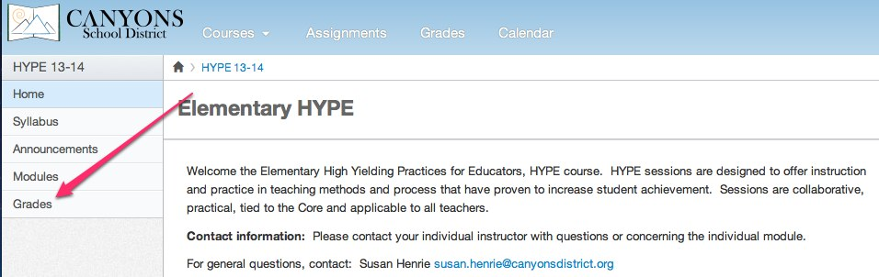
- How can I find out which HYPE classes I completed in previous year(s)?
You were invited to the HYPE course on Canvas. There you will see, under “Grades”, if you took the attendance quiz. This will tell you if you attended the HYPE course.

- Who can attend HYPE?
All elementary teachers are welcome to come to HYPE.

- Is there a stipend available for attending HYPE?
There is a $400.00 stipend available upon completion of HYPE certification.

- I am a teacher that is HYPE certified; will I be eligible for a stipend?
The stipend is available to be earned only once. If you come for more classes, you may earn recertification hours or CACTUS credit.

- I am a principal, coach, EdTech or other specialist, may I become HYPE certified?
Yes, you are eligible. Assignments will be modified to address your specific role and needs as determined by the instructor of the HYPE session.

- What is the experiential assignment and how long will it take?
The experiential assignment is a time for participants to apply learning from a HYPE session. Each experiential assignment will focus on a public practice and contains a plan, lesson, reflection and refinement suggestions. Each assignment should take about 45 minutes. Nine assignments are due to become HYPE certified.

- What if my school is doing HYPE for Professional Development, may I use those courses toward certification?
The courses offered for schools are a HYPE Highlight. Schools that have asked for HYPE content have customized the delivery for the school with the assistance of the principal, external coach and Achievement Coach. These school-based HYPE Highlights are not eligible for CACTUS credit and HYPE certification.

